Get into the game at the MOVE Congress 2019

Call for Innovation Alley exhibitors and presenters
This is an open call for any individual or organisation who wants to exhibit and/or present at one of the world’s most interactive conferences on grassroots sport and physical activity – the MOVE Congress on 16-18 October 2019 at the Budapest Congress Center. We are looking for exhibitors and presenters who are working with an innovative approach or technology that gets people moving.

What is the MOVE Congress?  The MOVE Congress is one of the few conferences in the world that focuses solely on recreational sport and physical activity. The event gathers organisations and individuals who deliver initiatives at the grassroots level along with decision-makers, companies, urban planners, health experts, academics and other key stakeholders for three days of active networking. This will be the 9th edition of the MOVE Congress. | 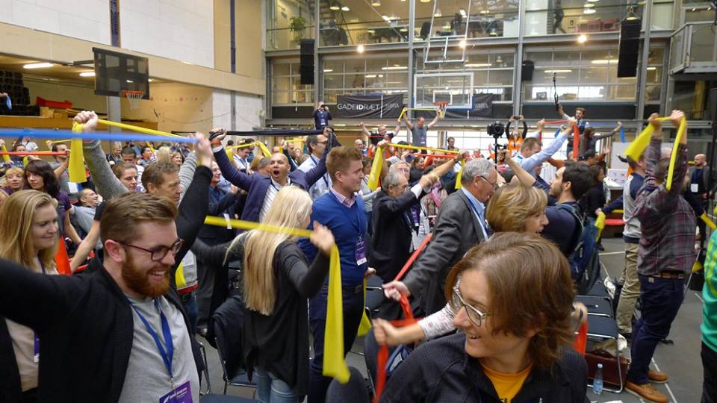
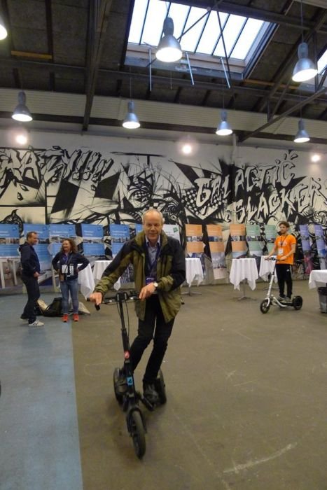 | Why exhibit at the MOVE Congress?  Because our participants like trying new things. And they love finding out about new approaches, technologies and equipment that inspire people of all ages to get active.  You can meet up to 500 of these grassroots sport and physical activity promoters at the MOVE Congress 2019.  If you don’t have a gadget for them to try, no problem! You can also submit an idea for a poster or an oral presentation. Just provide the information requested below and feel free to contact us to see if your idea would be a good fit.  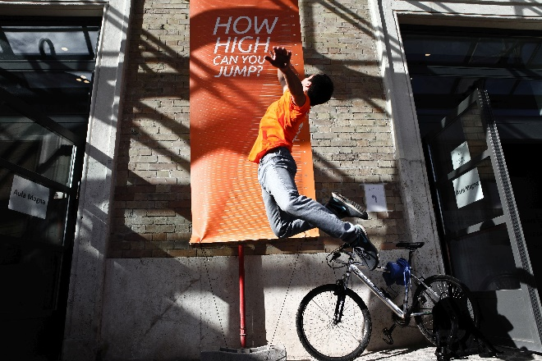

What’s your next MOVE?
Fill in the details requested below and send your application to contact@movecongress.com no later than Wednesday 31 July 2019 to be in the running to exhibit or present at the MOVE Congress 2019.

MOVE Congress 2019 venue map

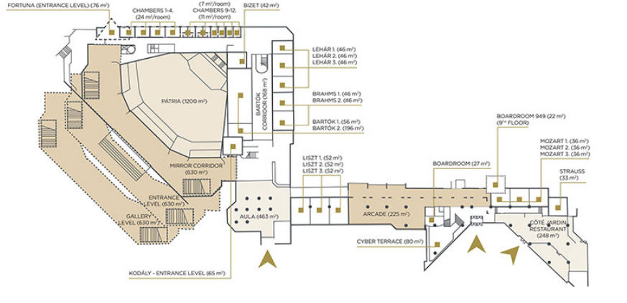

Main auditorium

Innovation Alley

Information to be included in the application (please complete the form below in English)
Your name:
Contact details (e-mail and telephone):
Role in your organisation:
Organisation (name, address, website link):
Organisation description (max 300 words):
Why are you and your organisation interested in presenting at the MOVE Congress 2019 (max 300 words)?:

Please highlight which exhibition or presentation opportunity you wish to apply for and then fill in the information required for that category below:
- Hands-on innovative technology, equipment or physical activity: Yes/No
- Poster (approx. 120x160cm. Exact dimensions to be provided on selection): Yes/No
Optional: I am interested in doing a 10-minute oral presentation at the MOVE Congress: Yes/No

Please provide additional information for your selected category/categories:
Hands-on innovative technology, equipment or physical activity
- Title of your exhibit
- A description of the technology or activity (max 300 words) including a link to a website and/or pictures of the item or approach (how is it an innovation or game-changer? Who has it changed the game for?)
- Approximate measurement of the space you will need for your equipment and other equipment you may need for your stand
- Any other assistance you may need
Poster
- Title of your poster presentation
- Organisation, activity, project, research or product it represents
- Poster concept and plan (what will it show? How is it an innovative or game-changing approach? Who has it changed the game for?) (max 300 words)
- Any relevant links to websites related to the poster content
- Any other assistance you may need
Oral presentation
- An abstract for your 10-minute presentation (max 300 words)
- How does it connect with the main Congress theme Change the Game: It’s Your MOVE?
- Any relevant links to websites or videos connected to your presentation
- Technical requirements (i.e. projector or other)
- Any other assistance you may need

Deadline and selection process
31 July 2019: 2nd call application deadline
1-5 August 2019: MOVE Congress organisers the International Sport and Culture Association (ISCA http://isca-web.org/ ) and the Hungarian School, University and Leisure Sport Federation will review the applications.
From Monday 5 August: ISCA will notify the selected exhibitors and presenters.

Conditions
The MOVE Congress organisers will provide the space, high tables and electricity connections at the venue. Selected exhibitors or presenters must register at the current fee at the time of booking (you may also register before the selection is made, but it is not a requirement to apply as an exhibitor). The MOVE Congress fee covers entry to all sessions during the Congress and meals as provides as part of the standard fee (see the website for more information https://www.movecongress.com/ )
The selected exhibitors are also required to cover their own costs for travel and transportation to the MOVE Congress venue and accommodation in Budapest.
Please feel free to contact us at contact@movecongress.com if you have any specific inquiries.
If you are a for-profit company, please get in touch with the Secretariat before submitting your application as special conditions may apply.

