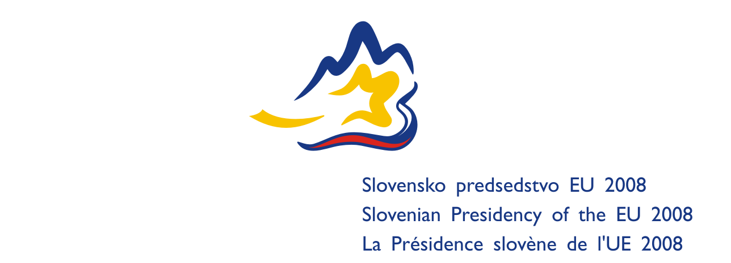

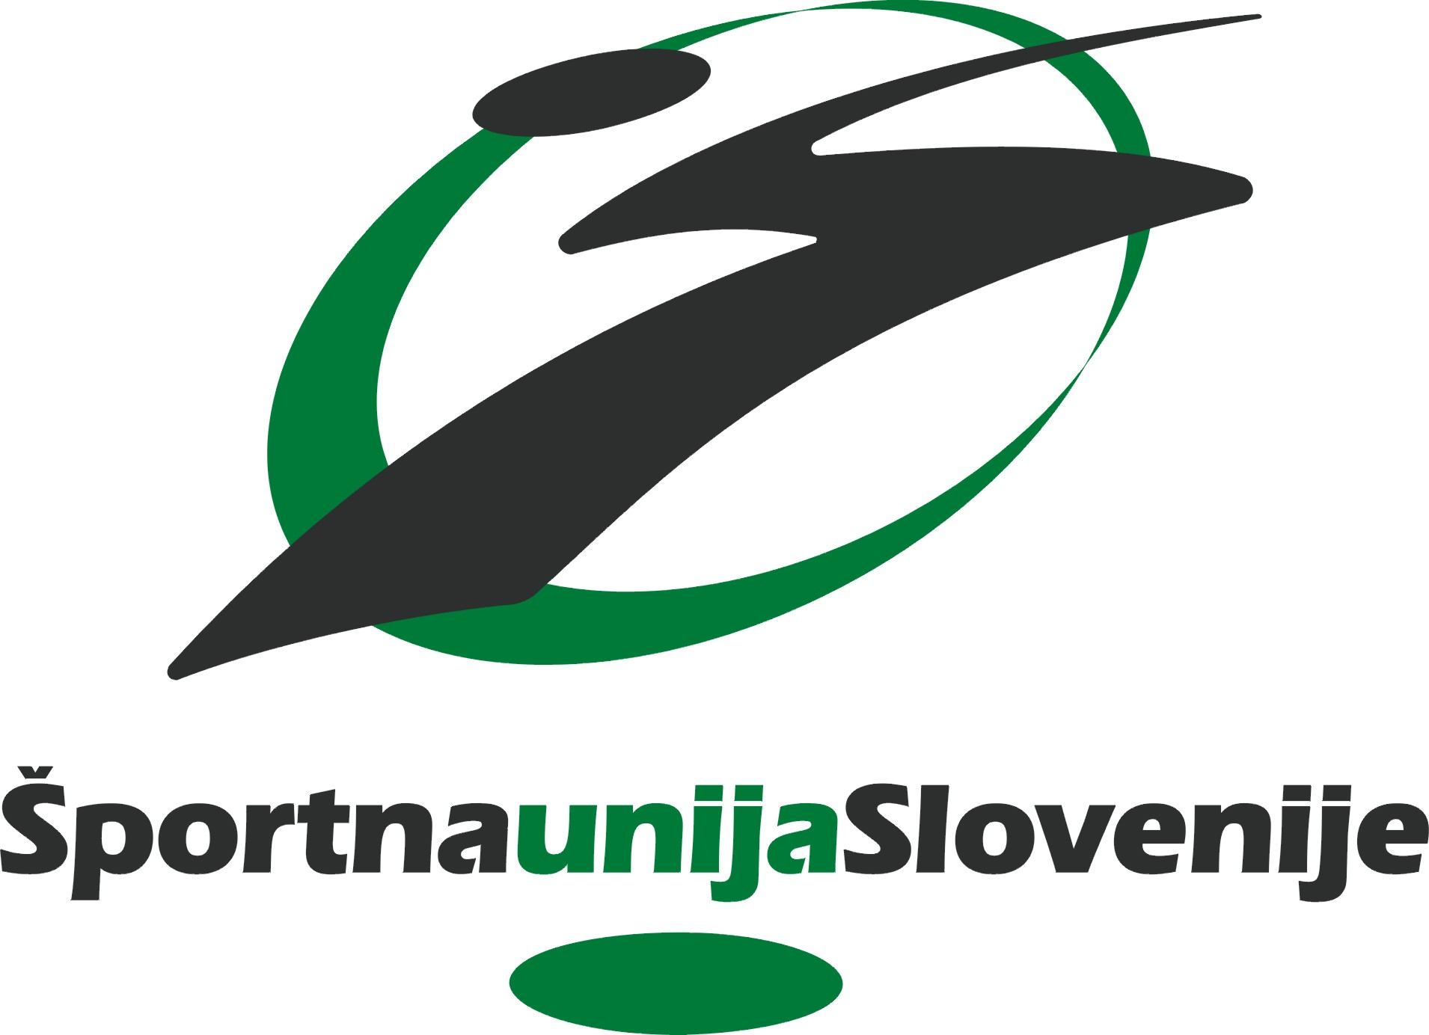


Ljubljana Sport for all Commitments

the result of

the International Round-table:

»SPORT FOR ALL AS THE ELEMENT OF INTERCULTURAL DIALOGUE«
Stimulate the Intercultural dialogue in EU with Sport for All activities and include into the EU integration.

Ljubljana, 15 th - 16 th May 2008

The round table focused on the following issues that are crucial for sustainable development of civil society through intercultural dialogue, exploiting the potential of “Sport for All” (SFA)

- What is the role of EU and stakeholders in developing a long - term strategy for the sport intervention and activities at local, national and international levels?
- How to encourage more SFA organisations for intercultural interventions?
- How to promote SFA not only in project implementation but also in shaping the EU and national programmes and polices?
- How could SFA organisations contribute to the role of sport in promoting social integration with common language and as a platform for democracy?

The round table resulted in the following commitments and policy recommendations to build SFA civil society dialogue and partnership relations between civil society, national governments, international NGOs and EU institutions.

The “National sport organisations” mentioned below are the organisations present at the Round Table. They make the commitments, and seek to engage other national sport organisations to do the same.

On the international level

ISCA and CESS commitments
- ISCA and CESS will activate and coordinate our South East European ‘sport for all’ network as an instrument in the EU enlargement process of Western Balkan. In 2008 we commit ourselves to enter in a dialogue with the European Commission directorates of Education and Culture, as well as Enlargement, on this matter.
- We collect, structure and disseminate knowledge, good practices and recommendations from national ‘sport for all’ organisations and other stakeholders. We invite you to follow the process at: www.interculturaldialogue2008.org
- We present a catalogue of recommendations at the European Sport Forum in Biarritz, France in December 2008, as a response to the EU White Paper on Sport.

Further international recommendations from the Round Table
- All international NGO umbrella organisations should engage in the cooperation and focused work to sustain intercultural dialogue, following the commitment of ISCA and CESS
- International – as well as national – organisations should engage in dialogue with the EU institutions to obtain recognition of sport for all to societal developments, in particular intercultural dialogue. Physical activity should become a common aspect of everyday life, and contribute to health-improving lifestyles.

On the national level

- The value of a holistic approach to intercultural dialogue must be recognised. National sport for all organisations will engage in commiting long term partnership with other stakeholders in education, employment etc. Likewise, national governments should ensure close cooperation and cross-sectoral, long term framework and policies to support a holistic and effective approach
- National sport for all organisations should engage in networking and exchange of best practises from local level, as well as support the build up of stable organisational structures to sustain the day-to-day intercultural dialogue that is needed to follow up on larger events and manifestations.
- Following the presentations and discussions in the Round Table, National sport for all organisations recognise their challenge and commitment to
- Prioritise intercultural dialogue in their national policies and priorities
- Be the practitioneers – the ones that engage in programmes and activities that actually enhance intercultural dialogue
- Create visibility around these activities to engage more people and more partners in the efforts
- Document success of their efforts to show evidence-based results

On the local level
- Intercultural dialogue through sport is essentially a local process, driven by committed sport clubs, organisations and individuals. This vital involvement should be driven by stable and capable organisational structures to ensure long-term initiatives, among others through the cooperation with and support from local governments.

